Project Design Phase
Problem – Solution Fit Template

Date | 15 February 2025
Team ID | Not specified in project brief
Project Name | Auto Ticket Classification using Flow Designer
Maximum Marks | 2 Marks

Problem–Solution Fit: School IT Ticket Classification
The project fits a frequent helpdesk problem: students and teachers need quick support, while IT agents need consistent, correctly routed ticket data.
Purpose:
- Match the user’s simple submission behavior with a no-code automation that removes manual categorization.
- Improve adoption by using the existing ServiceNow ticket form and email channel.
- Strengthen trust by confirming receipt and applying predictable Category/Subcategory rules.
- Reduce recurring operational annoyance: manual review, rework, and incorrect routing.
- Define the current situation and the measurable outcome for the school helpdesk.

Project Canvas:
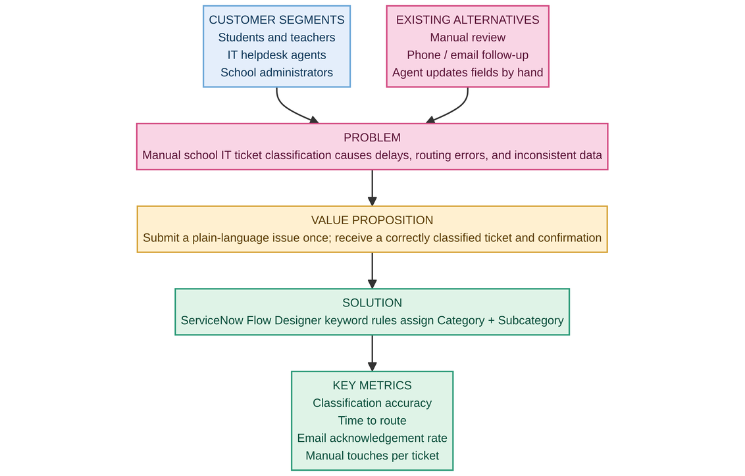
References:
- Source project: Auto Ticket Classification using Flow Designer
- ServiceNow Flow Designer and Incident Workflow configuration brief

